COMMUNICATIONS PLAN
Don’t Wait to inflate, a puget sound starts Here campaign
Contents
SUMMARY 1
BACKGROUND 1
Media/blog content 3
DESIGNATED SPOKESPEOPLE 8
KEY MESSAGES 8
Answers to Likely Questions 8
partners & pals toolkit 11
SOCIAL MEDIA calendar for puget sound starts here 15
CAR CARE MESSAGING FOR PUGET SOUND STARTS HERE 15
video scripts & text 22
APPENDIX 25

Summary
Drivers around Puget Sound can take a small action to help protect clean water: check car tire pressure monthly and add air as soon as possible if needed to reduce wear, save money – and save salmon. We will show drivers of any experience level how easy it is to check and inflate their car tires monthly for safer driving and cleaner water. Puget Sound and salmon are at risk from rainwater runoff that picks up pollutants like tire particles and washes them into local waterways. That runoff is carrying a newly identified toxic from tires: 6PPD-q. When tire crumbs soak in rainwater, 6PPD-q is released and kills coho salmon.

Background
The annual campaign is in two stages in 2023: one funded by a National Estuary Program grant that will end September 30, 2023 and the extended phase through the year end that is funded by contributions from regional partners working together on clean water outreach projects.
The regional partners that have contributed funding to the campaign are Seattle Public Utilities, King County, Pierce County, Snohomish County, Thurston County, Olympia, West Sound Stormwater Outreach Group, Kirkland, Duvall, Issaquah, Renton, Lynnwood, Auburn, Redmond, Tacoma, University Place, Everett, Sammamish, Tukwila, Bothell, Lake Forest Park, Marysville, Monroe, Shoreline, Burien, Edmonds, Lacey, Maple Valley, Mukilteo, Enumclaw and Normandy Park. Cities and project pals that have not contributed but help spread the campaign through their outreach are members of the STORM collaborative of stormwater managers. Nonprofits that are participating in the campaign include Zero Waste Washington, the King County ECO Net and Stewardship Partners. Contractors involved in developing the campaign include Rich Marketing, Bridge Latino, Nancy Lee, Lori Kothe, Tai Le, Burshek Research, and GA Creative.
The 2022 Puget Sound Starts Here campaign was based on research into the best practices that help reduce stormwater pollution. It focused on clean water actions related to car care pollution prevention practices, offered insights into audiences and messaging and built awareness of this obscure 6PPD-q compound. With recent research on the toxicity of 6PPD from tire crumb, the team decided to test public engagement about tire inflation to reduce tire wear. This message was chosen knowing that research had not yet been done to show a connection between tire inflation and potential release of 6PPD and tire crumb. Information was provided in English, Spanish, Korean and Vietnamese to mutually expand environmental awareness and understanding. Since that time, state agency staff working with the US Tire Manufacturers Association (USTMA) on reduction of tire wear particles (TWP) have confirmed that when tires are properly inflated, it does reduce tire wear particles.
This project has been funded wholly or in part by the United States Environmental Protection Agency under assistance agreement PC-01J18101 to the Washington State Department of Ecology. The contents of this document do not necessarily reflect the views and policies of the Environmental Protection Agency, nor does mention of trade names or commercial products constitute endorsement or recommendation for use.
The annual Puget Sound Starts Here campaign has been a regional collaboration since it began in 2008. The focus has been to raise awareness about stormwater pollution issues and influence environmental actions and community norms.

media/blog content
BLOG
Lori Kothe / Mary Rabourn, 26 Sept 2023 v2
Don’t wait to inflate!
Checking your tire pressure monthly helps drivers stay safer,
save money – and save coho salmon.
A recently discovered stormwater pollutant from cars is killing local coho salmon at an alarming rate, but the source might not be what you expect. Fuel emissions? Oil leaks? Dirty car wash water flowing down storm drains into our waters? Worse: a highly toxic rubber preservative in tire wear particles called 6PPD-q.
Local researchers, Washington Department of Ecology and tire manufacturers are working on new formulations to address the issue, but solutions will take time – and coho can’t wait. What can we all do now to help save the salmon? A new tire care campaign sponsored by the Puget Sound Starts Here team of local cities, counties, local nonprofit partners and Washington State Department of Ecology shows the answer is simple: “Don’t wait to inflate”.
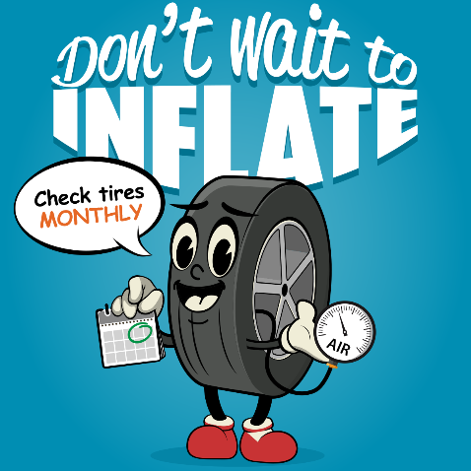
A campaign ad featuring Terry the Tire
A friendly mascot “Terry the Tire” and the DontWaitToInflate.org webpage share resources on how, when, and where to check air pressure and keep tires properly inflated. These include a short how-to video, a map of nearby air stations, car care tips and 6PPD-q research. Stickers and window clings will be distributed throughout the Puget Sound region thanks to local city, county and nonprofit partners.
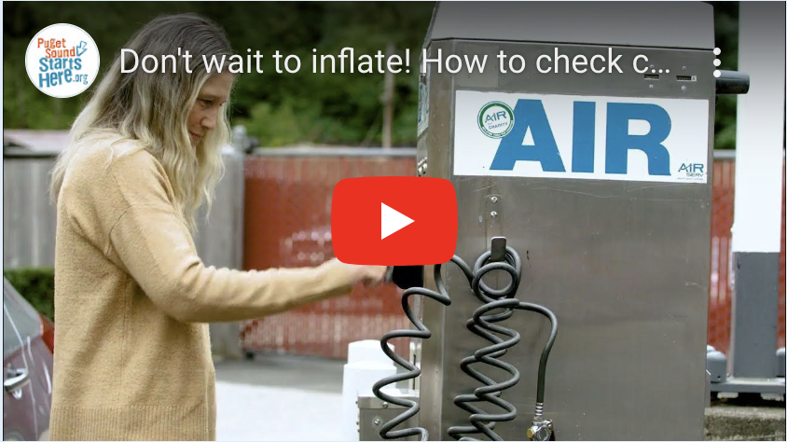
The “Don’t Wait to Inflate” campaign shows drivers how, when, and where to check their tire air pressure and keep tires properly inflated for safety, savings – and salmon!
The “Don’t Wait to Inflate” tire car campaign helps drivers make a difference by taking a simple action – check your tire pressure monthly and add air as soon as possible if needed. Ads will appear on digital channels and include paid digital display ads, digital native ads, animated video ads and social media ads as well as organic social posts.
Properly inflated tires can help keep people safer on the road, save money, and even save the lives of local coho salmon. As tires wear, they shed tire particles called tire crumb or dust that wash off roads into waters. The US Tire Manufacturers Association (USTMA) recommends checking tires at least once a month and inflating if low to help reduce tire wear particles. Tires maintained monthly at their ideal air pressure wear longer, reducing the rate of toxic pollutants released.
“Drivers can take a small action to reduce tire particles and help keep our waters cleaner and protect coho salmon,” said Mary Rabourn with King County Stormwater Services. “It’s an easy way to help our salmon and it’s safer for drivers too. By checking tire pressure monthly and adding air right away if needed, drivers save gas and tire wear, and help keep water clean.”
Research findings revealed that nearly 33% of Puget Sound area residents currently check their tire pressure monthly. Of those who don't, 65% of respondents said they are somewhat to very likely willing to check their tire pressure monthly if they are shown how. The campaign shows drivers who have never done it before how fast and easy it can be. And it encourages those who may be checking their tire pressure less frequently to commit to checking it monthly. The research and campaign information includes feedback from English, Spanish, Korean and Vietnamese language users from around Puget Sound.
We also heard from Puget Sound area drivers that they preferred a focus on safety, savings, and helping to protect our salmon.
A friendly mascot “Terry the Tire” and the DontWaitToInflate.org webpage share resources on how, when, and where to check air pressure and keep tires properly inflated. These include a short how-to video, a map of nearby air stations, car care tips, and 6PPD-q research. Stickers and window clings will be distributed throughout the Puget Sound region thanks to local city, county and nonprofit partners.
“We want to help people discover that if you can pump gas or charge your car, you can check your tire pressure monthly and add air for safer driving and cleaner water. It’s that easy for drivers at any experience level. Or take it to your local service station and ask them to check for you. It’s good for drivers, coho salmon and protecting Puget Sound. So why wait?” – Justine Asohmbom, Washington Department of Ecology
“The Don’t Wait to Inflate” campaign not only raises awareness about personal and environmental benefits of tire care. It opens the door to making other small changes to car care and our daily activities at home, in the yard, with dogs and in our communities. Collectively we can make a big difference in Puget Sound recovery and keep pollution out of our waterways.” – Susan McCleary, City of Olympia
To learn more and share the campaign, visit DontWaitToInflate.org and follow @PugetSoundStartsHere #DontWaitToInflate on Instagram and Facebook.
About the 2023 Puget Sound Starts Here campaign
The annual Puget Sound Starts Here campaign has been a regional collaboration since it began in 2008. The focus is to raise awareness about rainwater pollution issues and influence environmental actions and community norms. Partners use social marketing practices to focus on audiences and create relevant information on clean water actions.
The annual campaign is in two stages in 2023: one funded by a National Estuary Program grant that will end September 30, 2023 and the extended phase that is funded by contributions from regional partners working together on clean water outreach projects.
Partners around Puget Sound that have contributed funding to the campaign are Seattle Public Utilities, King County, Pierce County, Snohomish County, Thurston County, West Sound Stormwater Outreach Group, Kirkland, Duvall, Issaquah, Renton, Lynnwood, Auburn, Redmond, Tacoma, University Place, Everett, Sammamish, Tukwila, Bothell, Lake Forest Park, Marysville, Monroe, Shoreline, Burien, Edmonds, Lacey, Maple Valley, Mukilteo, Enumclaw, Normandy Park and Olympia. Cities and others that have not contributed help spread the campaign through their outreach are members of the STORM collaborative of stormwater managers and the EcoNets, an environmental nonprofit network.
Nonprofits that are participating in the campaign include Zero Waste Washington, the King County ECO Net and Stewardship Partners.
Contractors involved in developing the campaign include Rich Marketing, Bridge Latino, Nancy Lee, Lori Kothe, Tai Le, Burshek Research and GA Creative.
This project has been funded wholly or in part by the United States Environmental Protection Agency under assistance agreement PC-01J18101 to the Washington State Department of Ecology. The contents of this document do not necessarily reflect the views and policies of the Environmental Protection Agency, nor does mention of trade names or commercial products constitute endorsement or recommendation for use.
To learn more, visit PugetSoundStartsHere.org
****

News Release
September 27, 2023
“Don’t Wait to Inflate” reminds drivers to check tire pressure monthly for safety, savings – and salmon!
SUMMARY
“Don’t Wait to Inflate” helps drivers make a difference by taking a simple action – check your tire pressure monthly and add air as soon as possible, if needed. Keeping tires properly inflated improves road safety and gas mileage and helps reduce toxic pollutants from tires from getting into our creeks and lakes. New studies show a chemical in tire rubber called 6PPD-q is killing coho salmon. By keeping your tires properly inflated you can reduce tire dust and protect salmon and Puget Sound. Visit DontWaitToInflate.org to learn more.

STORY
“Don’t Wait to Inflate” helps drivers make a difference by taking a simple action – check your tire pressure monthly and add air as soon as possible, if needed. Keeping tires properly inflated improves road safety and gas mileage and helps keep toxic pollutants out of our creeks, lakes and Sound.
New studies show a chemical in tire rubber called 6PPD-q is killing coho salmon. By keeping your tires properly inflated you can reduce tire dust and protect salmon and Puget Sound. Visit DontWaitToInflate.org to learn more.

This clean water project is sponsored by the Puget Sound Starts Here team of local cities, counties, nonprofit partners and Washington State Department of Ecology. “We asked and found that 65% of Puget Sound residents are somewhat to very likely to check their tire pressure monthly if they knew the benefits and were given resources to learn how. This campaign gives people the information to take smart actions for their wallet and the environment,” said Mary Rabourn with King County Stormwater Services.

DontWaitToInflate.org features Terry the Tire, a mascot that reminds drivers to keep tires properly inflated, a video that shows drivers how to check their tire pressure and how to fill tires, an online map to find nearby air stations and more resources. It’s easy for drivers at any experience level to check their tire air monthly and inflate them to the proper pressure, or stop by a local service station and ask them to check the tire pressure.

Investigations by University of Washington and Washington State University scientists of 6PPD, a key chemical that comes from tire particles in rainwater runoff, have shown that the chemical is killing coho salmon. 6PPD is a chemical used to help tires last longer. A statewide team coordinated by the Washington Department of Ecology is working with tire manufacturers to create safer alternatives, but that will take time. We can all take the easy and safe action of checking our tire pressure monthly and keeping tires properly inflated. This reduced the number of particles that come off and dust our roads and runoff in rainwater. For more on 6PPD, and other clean water car tips, visit PugetSoundStartsHere.org.

RELEVANT LINKS
DontWaittoInflate.org
PugetSoundStartsHere.org

Animated videos
English :15 second animated video
English :30 second animated video

How to video (language versions in Spanish, Korean, Vietnamese to be added soon)
Don't wait to inflate! How to check car tire pressure monthly and add air ASAP if needed

QUOTES (Insert your quotes here)
“We asked and found that 65% of Puget Sound residents are somewhat to very likely to check their tire pressure monthly if they knew the benefits and were given resources to learn how. This campaign gives people the information to take smart actions for their wallet and the environment.” – Mary Rabourn with King County Stormwater Services

FOR MORE INFORMATION, CONTACT (Insert your info):
Mary Rabourn, King County Department of Natural Resources and Parks, 206-291-5003

Designated Spokespeople
- Justine Asohmbom, Puget Sound Education Coordinator, Washington State Dept of Ecology
- Heather Trim, Executive Director, Zero Waste Washington and King County ECO Net
- Aaron Hussman, Education and Outreach Specialist, City of Kirkland
- Mary Rabourn, Project Manager, King County

Key Messages

Don’t wait to inflate – check your tire pressure monthly. If needed – fill tires with air as soon as possible. Save money, prevent tire wear – and save salmon too! Safer for driving and salmon.

Tires filled to the correct air pressure wear longer, save gas and improve mileage and reduce toxic tire chemicals in our waters.

Use a tire gauge to check for the proper tire pressure. Locate the ideal tire pressure on the driver side door sticker or in the vehicle maintenance book. Fill with air at a local air station while checking to see if the air is at the proper pressure.

Low tire air creates tire wear and tire particles that release 6PPD-q into stormwater – a chemical that is toxic to salmon.

US Tire Manufacturers Association recommends checking tires at least once a month and inflating if low to help prevent tire wear particles.

Small actions can make a big difference for Puget Sound!

Answers to Likely Questions
Q: Why Don’t Wait to Inflate?
A: This is the most recent annual Puget Sound Starts Here clean water campaign by city, county and nonprofit partners working together to prevent stormwater pollution. The team wanted to share information about toxics from tire crumb that has been shown to kill coho salmon: 6PPD and its byproduct 6PPD-q. Based on audience and industry research, we focused on how drivers can help reduce that pollutant through an easy action: checking tire pressure monthly and keeping tires properly inflated.
The regional partners contribute to the annual campaign. The 2023 campaign is funded wholly or in part by the United States Environmental Protection Agency under assistance agreement PC-01J18101 to the Washington State Department of Ecology.
The contents of this document do not necessarily reflect the views and policies of the Environmental Protection Agency, nor does mention of trade names or commercial products constitute endorsement or recommendation for use.
Q: What is 6PPD?
A: 6PPD is a chemical used in tire manufacturing that when exposed to air, reacts with ozone and transforms into 6PPD-quinone (pronounced "qui-KNOWN"), also referred to as 6PPD-q, a toxic that kills coho salmon. It is one of the chemicals added to extend the wear of tires.
Q: Who is working on this chemical in tires and how can I get information?
A: A team of scientists, Washington State Dept. of Ecology and tire manufacturers are researching how to create a “Salmon Safe tire” as Dr. Ed. Kolodziej, a lead University of Washington, Tacoma researcher, requested. Read about the state’s plans at Focus on: Best Management Practices for 6PPD-q (wa.gov) and more on the research and researchers at Discovery of tire-related chemical that kills coho salmon sparks widespread response | (pugetsoundinstitute.org).

Q: If 6PPD is killing salmon in Puget Sound, what is the rest of the country doing to protect clean water?
A: Three Northwest Tribes, the Port Gamble S’Klallam, Puyallup and Yurok Tribes have petitioned the Environmental Protection Agency to ban 6PPD to protect salmon: KUOW - Tribes call for national ban on salmon-killing chemical in car tires. California has placed it on the priority list for replacement and requiring tire manufacturers to find safe alternatives.
And thanks to local scientists from University of Washington and Washington State University investigating the toxics killing salmon, the chemical 6PPD and the chemical it produces in the environment, 6PPD-q are being tracked. Thanks to their work, tire manufacturers are working on safer alternatives.
Q: Are there other sources of information to find out more?
A: Yes. If you want to learn more, here is a list from the early discovery to ongoing research:
FOR MORE ON 6PPD
2023
6PPD - Washington State Department of Ecology
Focus On: Reducing Sources of 6PPD (wa.gov)
California Requires Tiremakers to Look for Safer Alternatives to Chemical that Kills Coho Salmon | Department of Toxic Substances Control
Tribes Petition Environmental Protection Agency to Ban Toxic Chemical from Tires - Earthjustice
Indigenous Tribes Petition EPA over Hazardous Tire Chemicals (autoweek.com)
2022
Recent papers from our group: 6PPD-Q updates and the ongoing hunt for contaminants | (pugetsoundinstitute.org)
2020
How Scientists Tracked Down a Mass Killer (of Salmon) - The New York Times (nytimes.com)
Tire-related chemical is largely responsible for adult coho salmon deaths in urban streams | UW News (washington.edu)
Tire dust killing coho salmon returning to Puget Sound, new research shows | The Seattle Times
Researchers Reveal Why Seattle Salmon Bite the Dust After Rainstorms | Smart News| Smithsonian Magazine
Q: Why just tire crumb, aren’t there other car pollutants too?
A: Yes! Another campaign from Puget Sound Starts Here, Don’t Drip & Drive, showed vehicle owners how to look for car drips, work with mechanics to identify and fix leaks, and how to maintain your vehicle. Find that info at fixcarleaks.org.

Q: What is Puget Sound Starts Here?
A: Puget Sound Starts Here started in 2008 sharing small actions to help prevent stormwater pollution. Cities, counties and nonprofits around Puget Sound and the Salish Sea share information on our everyday sources of pollution. Toxics like pesticides, vehicle leaks, juice from dumpsters left open in the rain, leaking septic systems, pet waste (yes! Dog poop is still an everyday – sometimes three times a day – pollutant), car washing on the street and tire crumb. This is just a few of the ways we can all take a small action that adds up.

Q: What is the grant that funded the 2023 campaign?
A: The project has been funded wholly or in part by the United States Environmental Protection Agency under assistance agreement PC-01J18101 to the Washington State Department of Ecology. The contents of this document do not necessarily reflect the views and policies of the Environmental Protection Agency, nor does mention of trade names or commercial products constitute endorsement or recommendation for use.

Q: Really, still about the dog poop?
A: Yep. Every action adds up in a region with over 4 million of us going about our daily to-doos (that’s almost two thirds of the entire state’s population). And in 2018 – before pandemic pet adoptions – the American Veterinary Medical Association estimated 1.6 million dogs in Washington State and 1 million of them living in the Puget Sound area. If we are going to tackle the big stuff, we need to take care of (and bag and trash) the small stuff too.

DON’T WAIT TO INFLATE
partnerS & PalS CAMPAIGN toolkit
PUGET SOUND STARTS HERE 2023

ABOUT THE CAMPAIGN
The “Don’t Wait to Inflate” campaign reminds drivers to check tire pressure monthly for safety, savings – and salmon!
The “Don’t Wait to Inflate” campaign reminds drivers that keeping tires properly inflated is safer for people and salmon. Checking tire pressure monthly and adding air if needed improves road safety, tire wear and gas mileage and helps keep toxic pollutants out of our waterways.
New studies show a chemical in tire rubber called 6PPD-q is killing coho salmon. By keeping your tires properly inflated you can reduce tire dust and protect salmon and Puget Sound. Visit DontWaitToInflate.org to learn more.
HOW TO USE THIS TOOLKIT
Share on your social and outreach channels and let us know how it is going! We can feature and amplify each other’s reach and audiences. This toolkit gives partners and pals of Puget Sound Starts Here resources to share the “Don’t Wait to Inflate” message through links to the campaign landing page, videos, downloadable creative assets, hashtags and sample social media posts.
Questions? Contact team members Justine Asohmbom, Heather Trim, Aaron Hussman, Mary Rabourn and get connected. We will post updates at DontWaitToInflate.org and the Puget Sound Starts Here Blog – Communities working together to raise awareness of how our everyday actions impact waterways in the Puget Sound region and what we can do to prevent pollution.

LINKS
DON’T WAIT TO INFLATE CAMPAIGN WEBPAGE VANITY URL (redirects to English webpage):
www.DontWaitToInflate.org
WEBPAGE URL BY LANGUAGE:
English: https://www.pugetsoundstartshere.org/DontWaittoInflate
Korean: https://www.pugetsoundstartshere.org/DontWaittoInflate/ko.html
Spanish: https://www.pugetsoundstartshere.org/DontWaittoInflate/sp.html
Vietnamese: https://www.pugetsoundstartshere.org/DontWaittoInflate/vt.html
VIDEOS
- English (:15 sec) animated video: Don't Wait to Inflate! Properly inflated tires improve road safety and even protect our coho salmon.
- English (:30 sec) animated video: Don't Wait to Inflate! Properly inflated tires improve road safety and even protect our coho salmon
- English (2:51) how-to video: Don't wait to inflate! How to check car tire pressure monthly and add air ASAP if needed

CREATIVE ASSET DOWNLOADS ON FLICKR
- DWTI Campaign Album: STORM Outreach | Flickr (PSSH Don't Wait to Inflate Tire Care Campaign 2023 album) of brand, image, video & social media creative assets
- Photostream of all STORM Flickr images: STORM Outreach | Flickr (main Flickr site)

HASHTAGS
#DontWaitToInflate  #CheckTirePressureMonthly  #CheckTiresMonthly | #PugetSoundStartsHere  #TireTuesday (as relevant)  #TireTipTuesday (as relevant)

SAMPLE SOCIAL MEDIA POSTS View / Download graphics from Flickr album
Want to drive safer, save money & help keep toxic pollutants out of our waterways? Don’t wait to inflate! Check your tire pressure monthly & add air if needed. Learn more at www.DontWaitToInflate.org  #DontWaitToInflate #CheckTirePressureMonthly #CheckTiresMonthly #PugetSoundStartsHere | 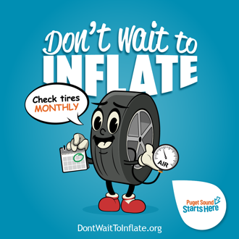
Don’t wait to inflate – your car tires, that is! Properly inflated tires result in better fuel efficiency & safer driving AND they help keep toxic pollutants out of our waterways – protecting local coho salmon.  📢Check your tire pressure monthly & add air ASAP if needed! It’s easy. To learn how & where to add air, go to www.DontWaitToInflate.org.  #DontWaitToInflate #CheckTirePressureMonthly #CheckTiresMonthly #PugetSoundStartsHere | 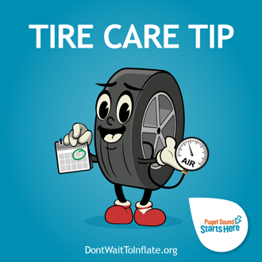
Here’s a monthly reminder to check the air pressure in your tires & inflate if needed! You can drive safer, save money, and help save our coho salmon from toxic pollutants in tire dust by keeping your tires properly inflated. It’s important to check monthly & add air if needed ASAP.  Learn more at www.DontWaitToInflate.org.  #DontWaitToInflate #CheckTirePressureMonthly #CheckTiresMonthly #PugetSoundStartsHere | 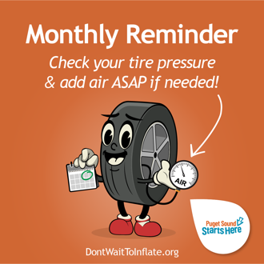
Fall in love with tire care this fall by checking the air pressure in your tires monthly! Think you can’t do it? We promise, you can! It’s quick and easy to check your tire pressure and add air if the pressure is low. Learn how by watching this brief video from Puget Sound Starts Here:  https://www.youtube.com/watch?v=9hMrOFzxuiU  #DontWaitToInflate #CheckTirePressureMonthly #CheckTiresMonthly #PugetSoundStartsHere | 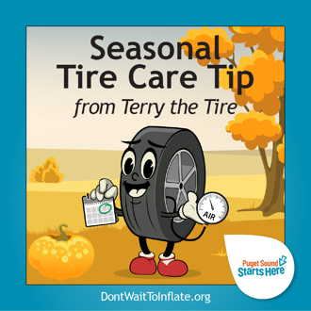
Cozy up to tire care this winter & check your air pressure monthly! You’ll stay safer on our wintery roads with properly inflated tires. If you’re not sure how, or to find an air station near you, visit www.DontWaitToInflate.org.  #DontWaitToInflate #CheckTirePressureMonthly #CheckTiresMonthly #PugetSoundStartsHere | 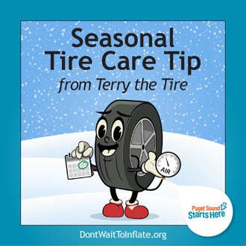
Put a spring in your car’s step with proper tire care! Properly inflated tires help you stay safer on the road when driving on Puget Sound roadways this spring…no winter…no summer…oh, it’s spring again! No matter what our indecisive weather does, it’s important to check your tire pressure monthly & add air if needed ASAP.  Find a nearby air station & learn more at: www.DontWaitToInflate.org.  #DontWaitToInflate #CheckTirePressureMonthly #CheckTiresMonthly #PugetSoundStartsHere | 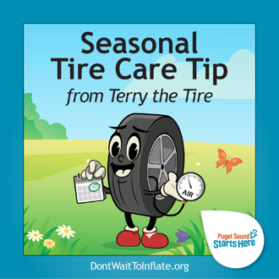
Here’s a hot tip to keep your tires cool this summer! Check your air pressure in the morning before the day heats up for the most accurate reading.  Have you checked your air pressure this month? If not, take a few minutes to check & add air ASAP if needed. It’ll save you money at the pump & your tires will last longer. Learn more at www.DontWaitToInflate.org.  #DontWaitToInflate #CheckTirePressureMonthly #CheckTiresMonthly #PugetSoundStartsHere | 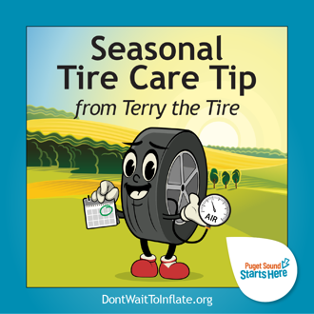

BRAND ASSETS View / Download from Flickr album
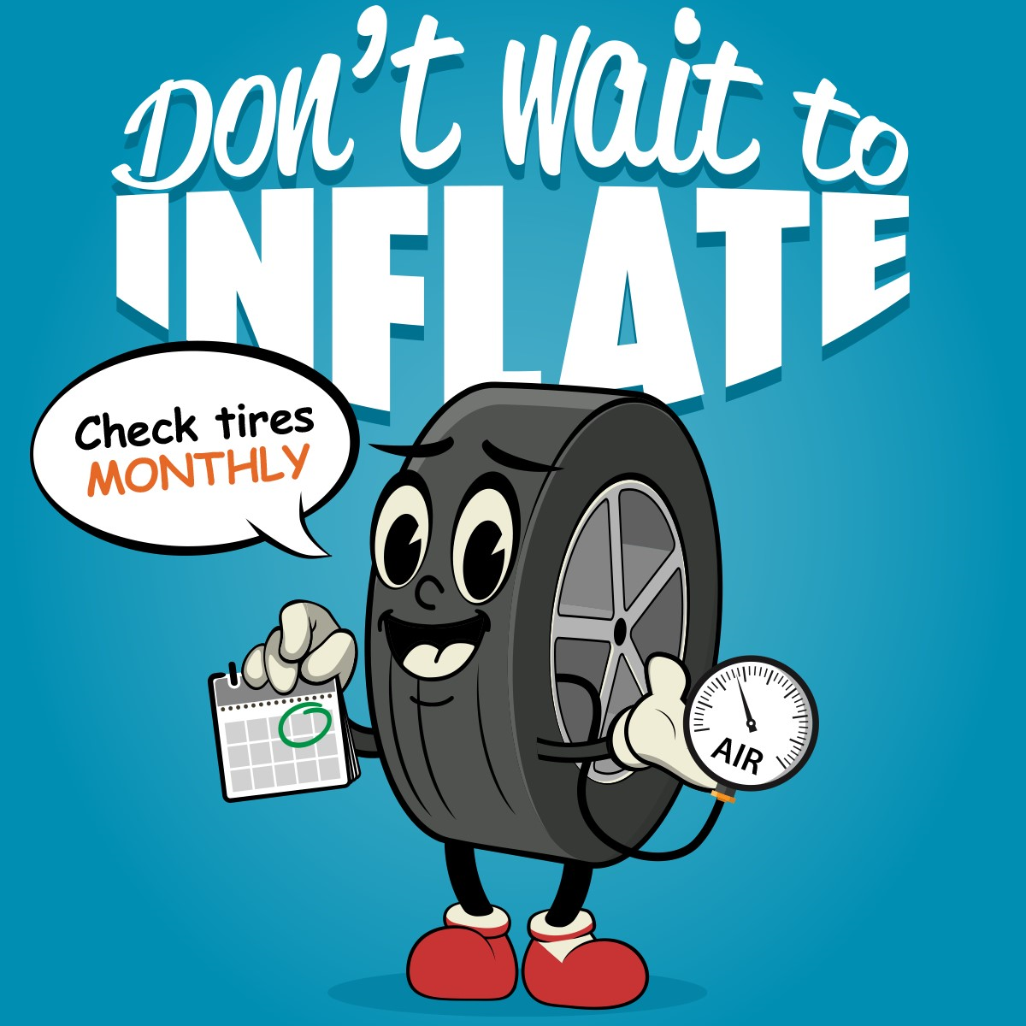 | 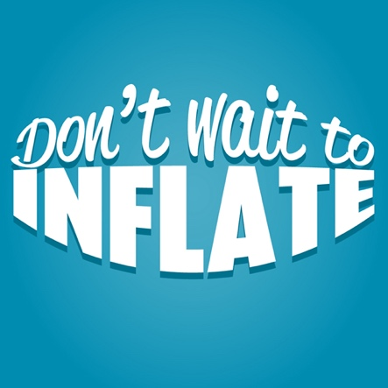 | 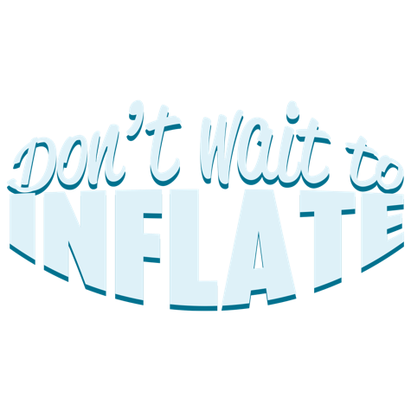
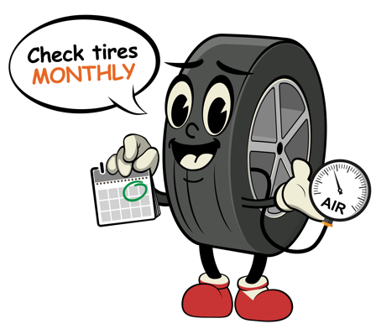 | 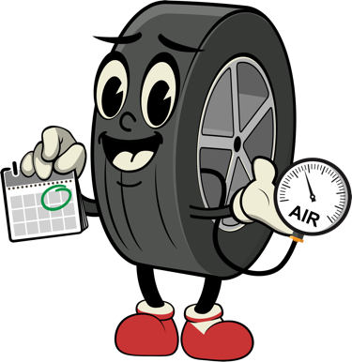
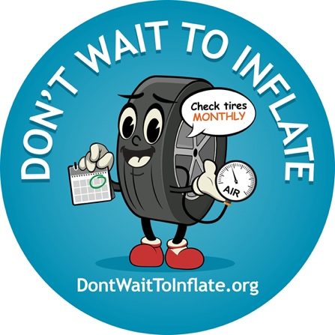

IMAGES View / Download from Flickr album
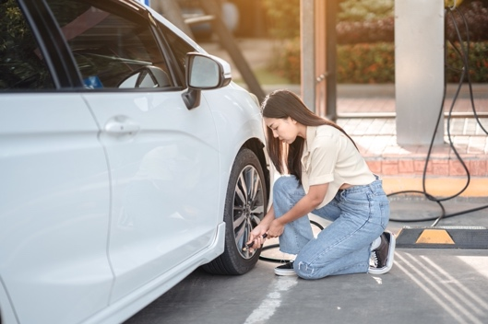 | 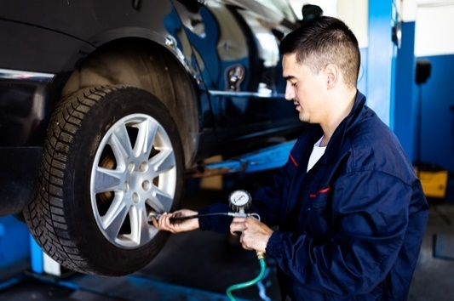

INTERACT WITH US ON SOCIAL
www.facebook.com/PugetSoundStartsHere
https://www.instagram.com/pugetsoundstartshere/
#PugetSoundStartsHere
@PugetSoundStartsHere

ADDITIONAL project materials & toolkits
STORM Resource Reservoir: https://www.pugetsoundstormgroup.org/  Puget Sound Starts Here website: https://www.pugetsoundstartshere.org/  Window clings or stickers: contact the partners or Mary.Rabourn@kingcounty.gov | 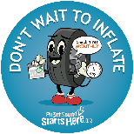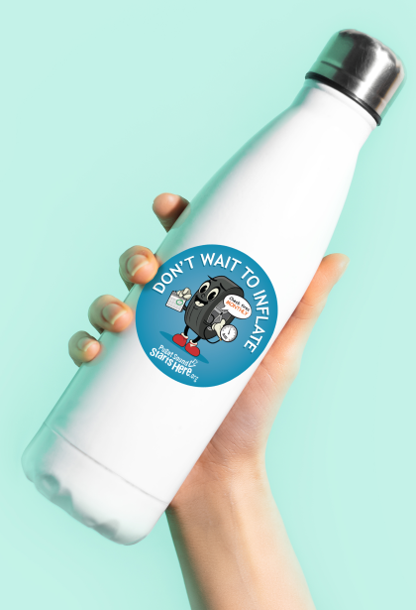

social MEDIA calendar for puget sound starts here

View and download campaign-specific creative assets in this Flickr album on the main STORM Outreach | Flickr site.
CALENDAR
Scheduled organic campaign frequency/cadence:
First 8 weeks: post min. 2x per week, Tuesday & Friday
Thereafter: Post min. 1x per week on “Tire Tip Tuesday”

MONTHLY - First Tuesday of each month: Monthly Reminder
Use Terry the Tire “monthly minder” creative.
#TireTipTuesday #DontWaitToInflate #CheckTiresMonthly #CheckTirePressureMonthly #MonthlyReminder #TireTuesday

WEEKLY - Tire Tip Tuesday: Tire Care Tip
Use Terry the Tire “tire care tip” creative or other image.
#TireTipTuesday #DontWaitToInflate #CheckTiresMonthly #CheckTirePressureMonthly #PugetSoundStartsHere #TireTuesday

SEASONAL - First week of each season: fall | winter | spring | summer
Use Terry the Tire seasonal graphic or other image.
#DontWaitToInflate #CheckTiresMonthly #CheckTirePressureMonthly #PugetSoundStartsHere

Car Care Messaging for puget sound starts here

Why tire inflation?
When it rains, pollution from cars wash into storm drains, and then straight into local streams, lakes, rivers, and Puget Sound. Pollutants like oil, car wash soaps and chemicals, and bits of tire dust are bad for water quality and harm people and wildlife, like salmon and orcas, that depend on clean water to survive. We can keep pollution out of our creeks, lakes, rivers and Puget Sound. Our small actions add up to a BIG difference for Puget Sound, the Salish Sea, and marine life!

Make these small changes in car care for a cleaner Puget Sound and future:

Tire maintenance
Action 1: Check your tires monthly and keep them properly inflated.
Action 2: Get your tire alignment checked and rotate tires according to the manufacturer’s instructions.
Action 3: Always dispose of used tires properly.

Wash right
Action 1: Use a commercial car wash to keep our waters clean.
Action 2: Wash your car on a grassy area to soak up the dirty wash water.
Action 3: If you wash in the driveway, direct dirty water away from the street.

Don’t drip and drive
Action 1: Check your vehicle for leaks regularly and get them fixed promptly.
Action 2: Always dispose of used motor oil properly.
 | TIRE MAINTENANCE | WASH RIGHT |  | DON’T DRIP AND DRIVE
Why it matters:  Car tires have many chemicals that help protect them from damage. As we drive, the tires wear down, leaving tiny bits of tire behind on our roads. The chemicals in this tire dust are toxic to fish. When it rains, the runoff picks up the tire bits and carries them down storm drains and into our waterways. |  |  | Why it matters:  When you wash your car, the rinse water contains harmful pollutants like oil, grease, heavy metals and soaps. If you wash your car on the street or in your driveway, the pollutants run on the street and into the storm drain, and then flow untreated into our local creeks, lakes, rivers and Puget Sound. | Why it matters:  Even a small oil leak can have a big impact on your car and our creeks, lakes, rivers, and Puget Sound. Every drop in your driveway means a shorter lifespan for your car. Plus, oil and other petroleum products are toxic to people, wildlife, and plants and can contaminate the ground and our waters.
 | Proof points:  Taking care of your tires is the best thing drivers can do to reduce wear and prevent tire pollution.  Proper tire maintenance will extend the life of your tires and save you money.  Keeping tires properly inflated can increase gas mileage and slow tire wear.  Maintaining your tires and keeping them properly inflated help reduce tire pollution and keep humans and coho salmon safer. | Proof points:  It’s why in many communities it’s illegal to let that soapy water enter a storm drain. |  | Proof points:  Extends the life of your vehicle and keeps your driveway and street cleaner.

- Action 1: Check your tires monthly and add air ASAP if needed to keep them properly inflated.

MAIN POINT | TEXT | GRAPHIC
Tire dust is killing coho salmon; maintain your tires to keep you and salmon safer. | Oh no, coho! Scientists recently discovered a chemical in tire dust called 6PPD-q that’s highly toxic to coho salmon. You can help reduce tire pollution and improve safety by maintaining your tires and keeping them properly inflated.  #DontWaitToInflate  #PugetSoundStartsHere | 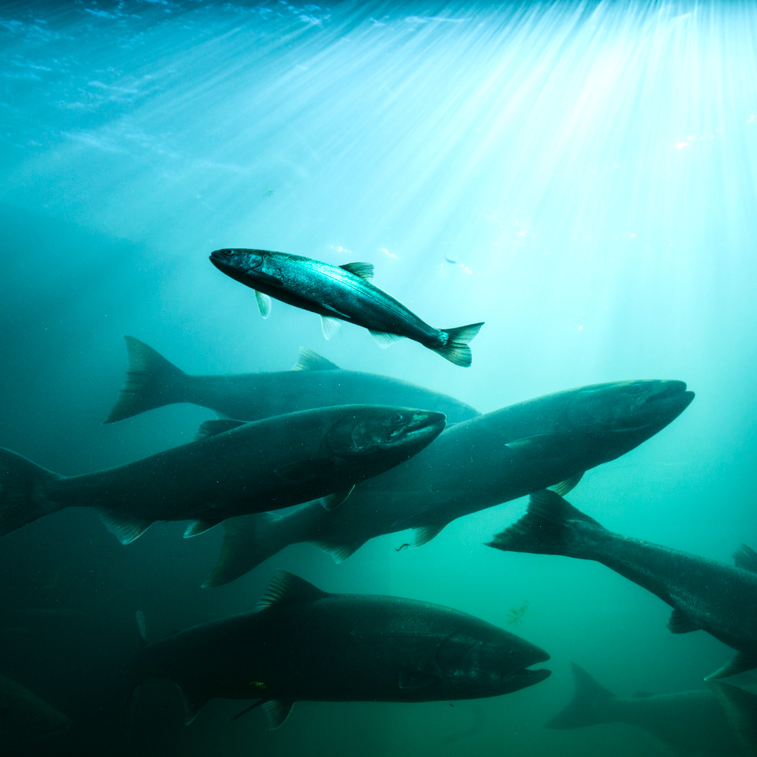
TIMING / SEASON

Anytime
LINKS (optional)  https://www.wastormwatercenter.org/research/tiresandsalmon/  https://DontWaitToInflate.org | Save more than the life of your tires! As we drive, tires wear down and leave tire dust that is toxic to fish, especially coho salmon. You can help prevent tire pollution and protect wildlife by keeping your tires maintained and properly inflated.  #DontWaitToInflate  #PugetSoundStartsHere

MAIN POINT | TEXT | SAMPLE GRAPHIC
Don’t wait to inflate; check tires monthly; find the ideal pressure. | Check your tire pressure once per month, either with your own pressure gauge or at a gas station air pump. Keep tires properly inflated so that they will wear down more slowly. What’s ideal? The number listed on a tire is not the ideal pressure. That’s the maximum. Look for a sticker inside the driver’s door or check your car’s manual to locate the ideal number.  #DontWaitToInflate  #CheckTiresMonthly  #PugetSoundStartsHere | 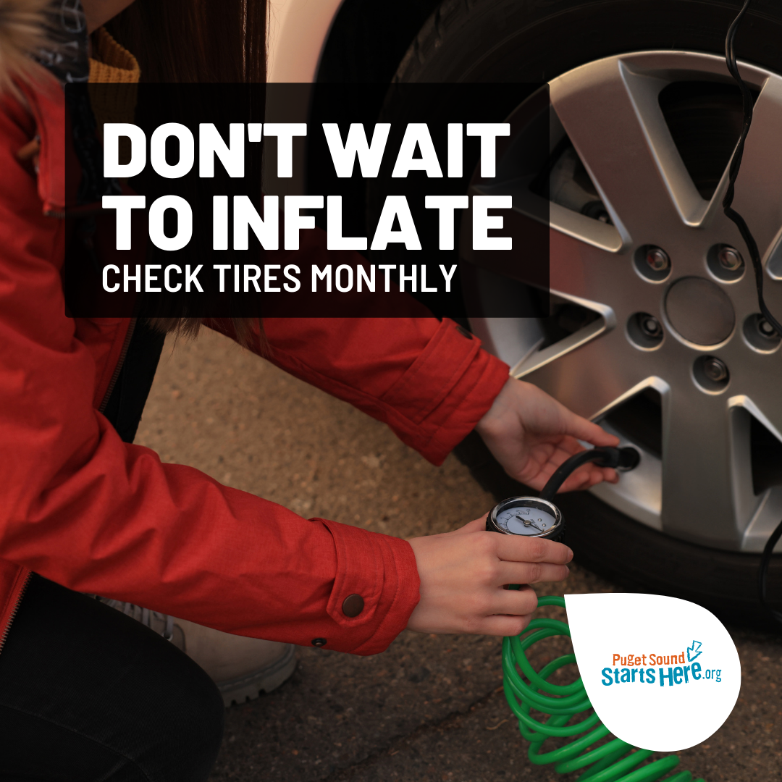
THEME

Best practices
TIMING / SEASON

Monthly
LINK (optional)

https://DontWaitToInflate.org

MAIN POINT | TEXT | SAMPLE GRAPHIC
Don’t wait for the low tire alert light; check tire pressure monthly. | #ProTip: Check your car tire pressure monthly and add air ASAP if needed. Don’t’ wait for a tire alert symbol on your dash. That’s dangerously low.  #DontWaitToInflate  #CheckTiresMonthly  #PugetSoundStartsHere | 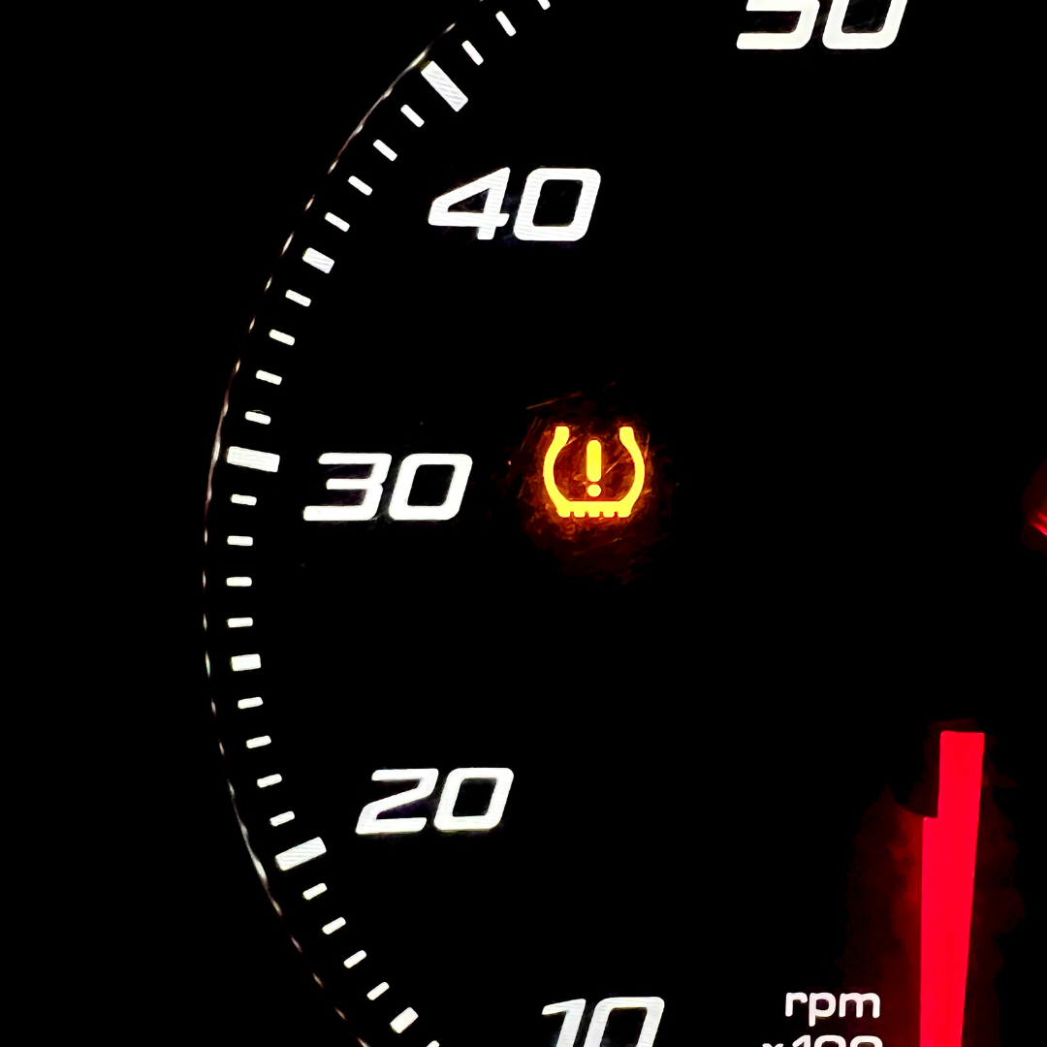
THEME
Safety and environment

TIMING / SEASON
Monthly
LINK (optional)
https://DontWaitToInflate.org

MAIN POINT | TEXT | SAMPLE GRAPHIC
Winter weather – cold weather affects tire pressure | Stay safer on the road. Check your tire pressure once a month in cold weather and fill them with air ASAP if needed.  #DontWaitToInflate  #CheckTirePressureMonthly  #WinterTireCare  #PugetSoundStartsHere | 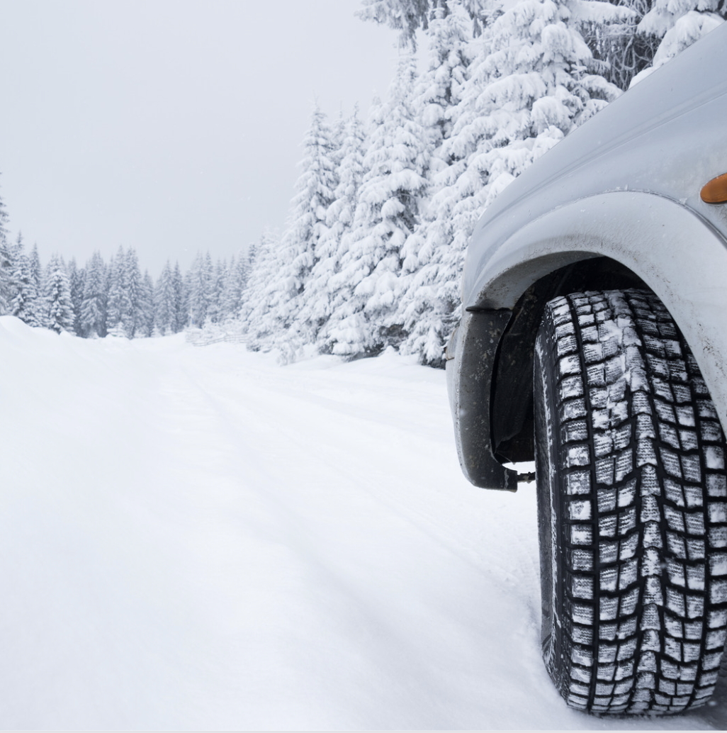
TIMING / SEASON

Cold weather / Fall & winter
LINKS (optional)

https://DontWaitToInflate.org

MAIN POINT | TEXT | SAMPLE GRAPHIC
Summer road trip time; don’t forget to check the tires | Hot tip: Check your tire pressure when your car tires have cooled. Once a month in the morning or a half hour after driving in hot weather. Fill them to the ideal pressure as needed. Learn how at DontWaitToInflate.org.  #DontWaitToInflate  #CheckTirePressureMonthly  #SummerTireCare  #PugetSoundStartsHere | 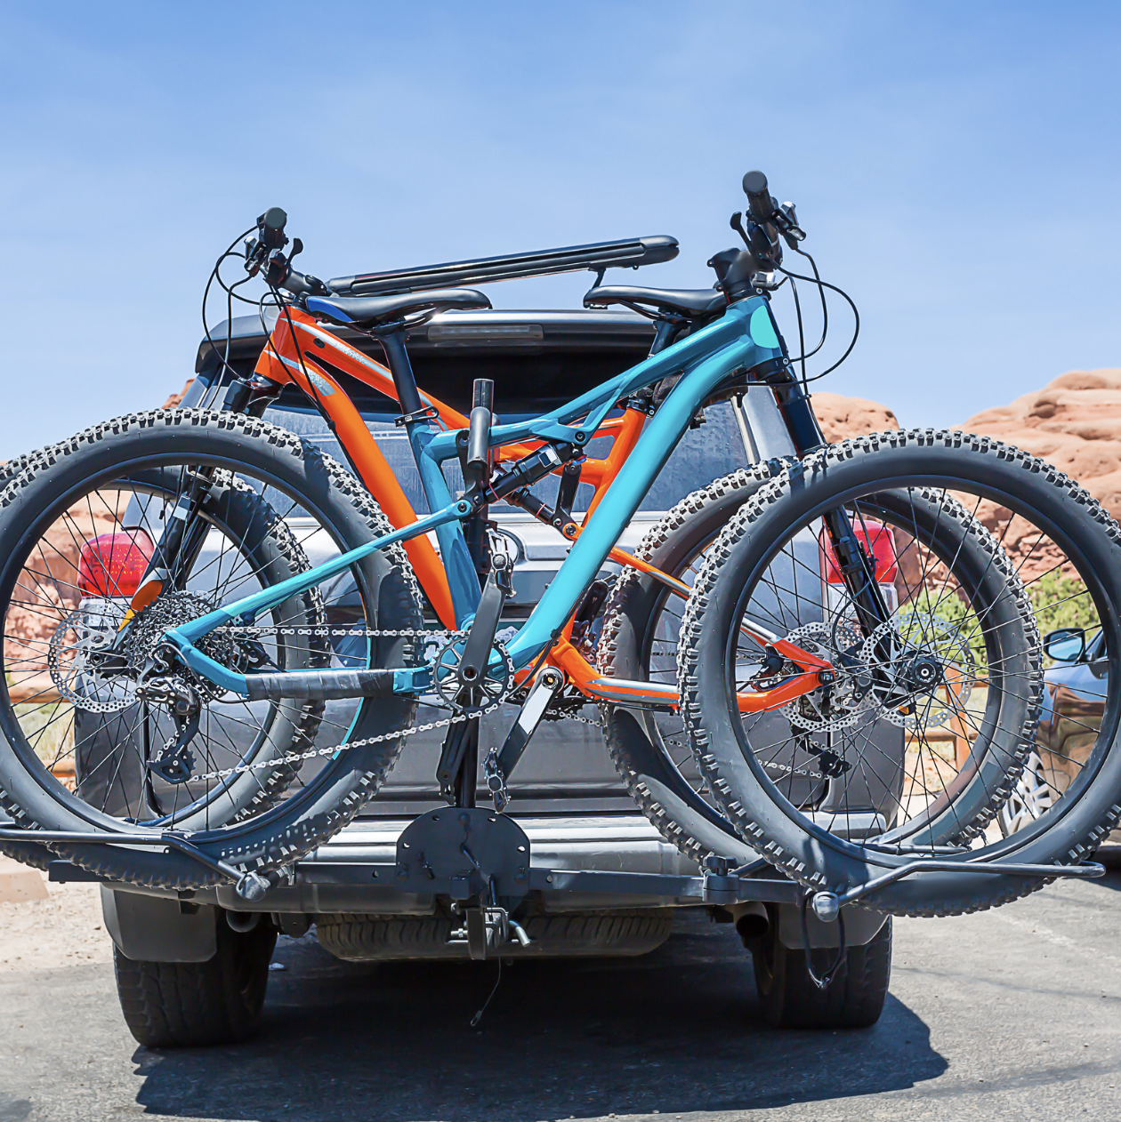
TIMING / SEASON
Road trip / Summer
LINKS (optional)
https://DontWaitToInflate.org

- Action 2: Get your tire alignment checked and rotate tires according to the manufacturer’s instructions.

MAIN POINT | TEXT | GRAPHIC
Proper tire maintenance will extend the life of your tires and save you money. | Get your tire alignment checked and rotate tires according to the manufacturer’s instructions. Proper alignment and regular rotation prevent uneven wear on your tires, reducing the amount of tire particles that wear off as you drive.  #PugetSoundStartsHere | 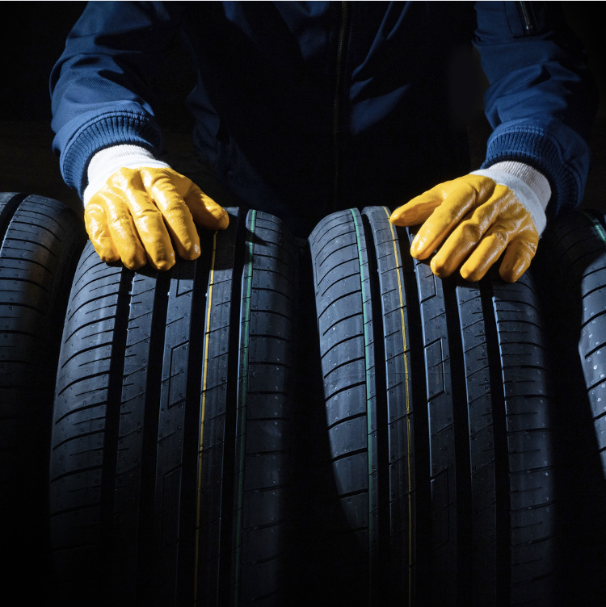
TIMING / SEASON
Anytime
LINKS (optional)
https://www.pugetsoundstartshere.org/CarCare/CarCareEnglish.html

- Action 3: Always dispose of used tires properly.
MAIN POINT | TEXT | GRAPHIC
Waste tires pose environmental and health hazards. | How to dispose of unwanted tires  Leave your old tires at the tire store when you buy new ones.  Ask your local transfer station if they accept tires.  Call 1-800-RECYCLE or visit 1800recycle.wa.gov to find a disposal location in your area. #PugetSoundStartsHere | 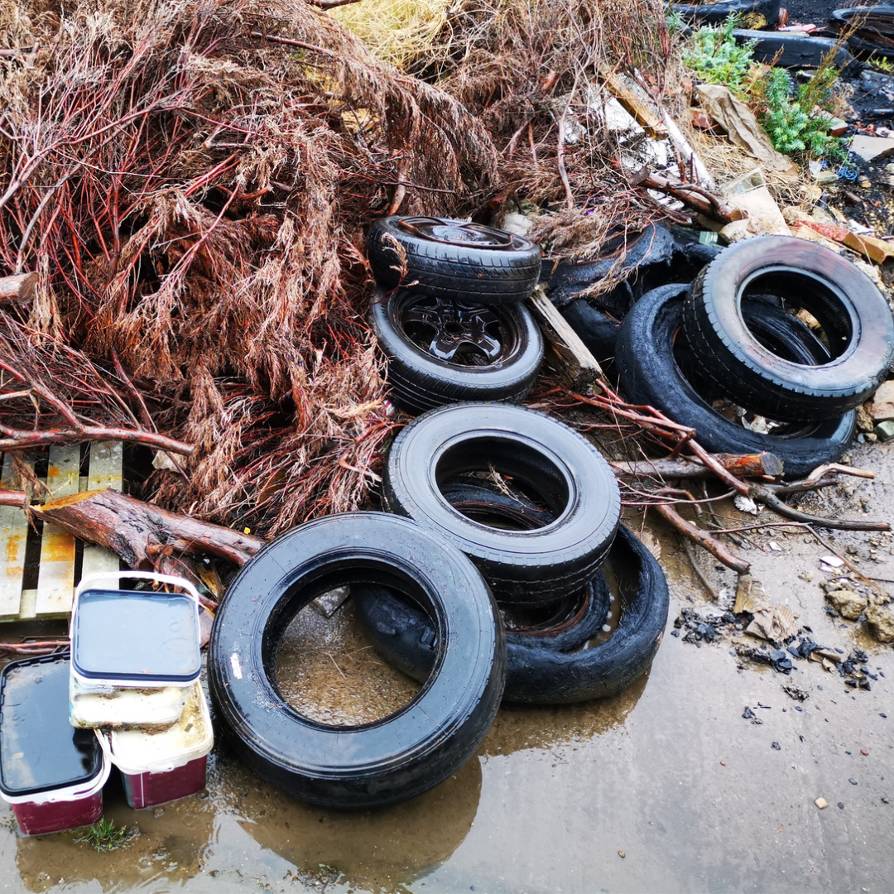
TIMING / SEASON

Anytime
LINKS (optional)

https://www.pugetsoundstartshere.org/CarCare/CarCareEnglish.html
https://ecology.wa.gov/Waste-Toxics/Reducing-recycling-waste/Waste-reduction-programs/Waste-tires

MAIN POINT | TEXT | GRAPHIC
Summer road trip time; don’t forget to check the car tires | Summer road trip time; don’t forget to check the car and bike tires. Check with your bike shop on your tire pressure and recycling those high mile tires. Learn how to check your car tires at https://DontWaitToInflate.org.  #PugetSoundStartsHere
TIMING / SEASON

Road trip / Summer
LINKS (optional)
https://www.pugetsoundstartshere.org/

https://DontWaitToInflate.org

video scripts & text
HOW-TO CHECK TIRES AND ADD AIR EXPLAINER VIDEO (2:51)
https://youtu.be/9hMrOFzxuiU
Step-by-step instructions on how to check your car tire pressure and add air if needed, and why it's important to keep your tires properly inflated.
Don’t wait to inflate! Checking tire pressure monthly and adding air as soon as possible if needed helps you stay safe, save money, and extend the life of your tires. It can even help save the lives of coho salmon. It’s simple and fast to check tire pressure with your own tire air pressure gauge or at an air station.
First, you'll need to know what pressure is right for your tires. Look for a sticker inside the driver’s door or check your car’s manual to locate the ideal number. The number listed on a tire is not the ideal pressure. That’s the maximum.
Next, you need a tire air pressure gauge. You can buy one at an auto parts store or online or borrow one from a friend or family member. You can also check your tire pressure and fill your tires with an air machine at gas stations and tire retailers or buy a portable one to use at home. It’s up to you! It’s best to check when your tires are cold, like in the morning or before you’ve driven a long distance to get a more accurate reading.
Think about what works for your schedule and set a monthly reminder to check your tires.
A tip about your car’s tire pressure monitoring system. Most warning systems kick-in only when there’s a critical problem, often not until a tire is dangerously low. Don’t wait for the alert!
Check tires monthly. To check the air pressure with your gauge, unscrew the valve cap on the tire. Press the gauge onto the valve stem firmly and you’ll hear a hiss of air. After a second, the gauge will show your tire pressure.
Compare the tire pressure reading from the gauge to the recommended pressure. Be sure to check all four tires. Often you can’t tell a tire is low just by looking at it.
If you need to fill your tires with air, head to a gas station or tire retailer — most have air machines. Park close enough to reach all the tires with the pump and read the instructions on the machine.
Remove the valve cap and keep it in a safe place. Next, attach the air hose to the tire valve. You’ll hear air flowing when you press the trigger. Add a little air at a time and keep checking until you reach the recommended pressure. If it’s lower, add air. If it’s higher, you might need to release some air.
When you’ve reached the recommended pressure in each tire, detach the hose, and don't forget to screw the valve caps back on. Checking tire pressure monthly and adding air as soon as possible if needed helps you stay safe, improves your vehicle’s gas mileage, and extends the life of your tires.
Plus, keeping your tires properly inflated helps protect salmon by reducing the amount of toxic tire dust washing into waterways. So what are you waiting for? Visit DontWaitToInflate.org to learn more.
Puget Sound Starts Here
***
Puget Sound Starts Here @PugetSoundStartsHere #DontWaitToInflate #CheckTirePressureMonthly #CheckTiresMonthly #PugetSoundStartsHere #carcare #tires #inflate #cohosalmon #howto
*** Dont Wait Inflate Final 230920a Sept2023 Eng
______________________________________
ANIMATED VIDEO AD (30 second):
https://youtu.be/lwtBu0qNvwY
Don't wait to inflate! Check tire pressure monthly. Puget Sound Starts Here
Did you know you should check the air in your tires once per month? Keeping your tires properly inflated increases road safety, improves gas mileage, and helps keep toxic pollutants out of our waterways. Don’t wait to inflate. Check your tire pressure monthly and add air if needed as soon as possible.
Learn more at www.DontWaitToInflate.org.
***
@PugetSoundStartsHere #DontWaitToInflate #CheckTirePressureMonthly #CheckTiresMonthly #PugetSoundStartsHere #carcare #tires #inflate
PSSH DWTI TireVideo 30 sec 1920x1080 Sept2023 Eng
______________________________________
ANIMATED VIDEO AD (15 SECOND)
https://youtu.be/Stlj9haiU2U
Don't Wait to Inflate! Properly inflated tires improve road safety and even protect our coho salmon.
Properly inflated tires improve road safety and even protect our coho salmon. Don't wait to inflate! Check your tire pressure monthly and add air if needed. Visit www.DontWaitToInflate.org.
***
Puget Sound Starts Here @PugetSoundStartsHere #DontWaitToInflate #CheckTirePressureMonthly #CheckTiresMonthly #PugetSoundStartsHere #carcare #tires #inflate #cohosalmon
PSSH DWTI TireVideo 15 sec 1920x1080 Sept2023 Eng

Appendix (and stuff if needed)

followup Partners
[Mentioned here for follow up about new campaign]
Informed | Partner
PATRICIA TOWNSEND, PH. D.
ENVIRONMENT and COMMUNITY OUTREACH SPECIALIST
College of Agriculture, Human, and Natural Resource Sciences
Washington State University
Office: 425 357 6020
Email: patricia.townsend@wsu.edu
STORM and partners:
The regional partners that have contributed funding to the campaign are Seattle Public Utilities, King County, Pierce County, Snohomish County, Thurston County, Olympia, West Sound Stormwater Outreach Group, Kirkland, Duvall, Issaquah, Renton, Lynnwood, Auburn, Redmond, Tacoma, University Place, Everett, Sammamish, Tukwila, Bothell, Lake Forest Park, Marysville, Monroe, Shoreline, Burien, Edmonds, Lacey, Maple Valley, Mukilteo, Enumclaw and Normandy Park. Cities that have not contributed but help spread the campaign through their outreach are members of the STORM collaborative of stormwater managers. Nonprofits that are participating in the campaign include Zero Waste Washington, the King County ECO Net and Stewardship Partners. Contractors involved in developing the campaign include Rich Marketing, Bridge Latino, Nancy Lee, Lori Kothe, Tai Le, Burshek Research, and GA Creative.

Assignments
Action | Lead | Status | Date needed | Comments
WEBSITE
INTERNAL/EXTERNAL COMMUNICATIONS
STORM
NEWS MEDIA
DIGITAL MEDIA
SOCIAL MEDIA
Send social media toolkit to partners
EVALUATION/TRACKING

