Appendix A
Regional Baseline Dumpster Data

l. Baseline Dumpster Data Summary
Dumpster audit data was available from six jurisdictions: Bellevue, Bothell, Federal Way, Kirkland, Redmond, and Sammamish. All data collected between 2015 and 2019. Audits inspected 451 total dumpsters. Lid status information was collected from 373 dumpsters, container leaking/damaged information was collected from 391 dumpsters, and a dumpster site condition rating was given to 147 dumpsters in Bellevue and Sammamish, using the City of Bellevue’s 2017 audit methodology.
A summary of the data reveals that:
  - Of the 373 dumpsters where lid status was noted, 128 lids (34%) were open or missing.
  - Of the 391 dumpsters where container leaking/damaged information was collected, 47 containers (12%) were observed to be damaged or leaking.
  - The average dumpster site condition given to the 147 dumpsters evaluated in Bellevue and Sammamish was 1.7 (scale of 1 to 3). Summary data reported in Table 1.1 below.
Data was analyzed to explore pollution by business type, use by single or multiple businesses, presence of proper labels, lid status and container status. Key findings include:
  - No statistically significant differences emerged based on business type. However, automotive businesses were slightly more likely to have lids open, while retail businesses were slightly more likely to have containers free of damage/leaks.
  - Dumpsters used by multiple businesses were significantly more likely to have containers with lids open and containers that were leaking/damaged.
  - Businesses with oil containers were significantly more likely to have leaking/damaged containers and had significantly higher dumpster condition ratings than businesses without oil containers.
  - Businesses with open lids were significantly more likely to have additional water quality concerns based on a 1-3 scale rating, compared to businesses with closed lids.
Table 1.1 – Summary dumpster audit data

Jurisdiction | # of Businesses | # With Lid Open | Percent Lids Open |  | # Inspected | # Leaking/Damaged | Percent Leaking/Damaged
Bellevue | 111 | 28 | 25% |  | 111 | 14 | 13%
Bothell | 102 | 35 | 34% |  | 102 | 2 | 2%
Federal Way | N/A | N/A | N/A |  | 78 | 20 | 26%
Kirkland | 61 | 29 | 48% |  | 61 | 3 | 5%
Redmond | 60 | 24 | 40% |  | N/A | N/A | N/A
Sammamish | 39 | 12 | 31% |  | 39 | 8 | 21%
Total | 373 | 128 | 34% |  | 391 | 47 | 12%

Business type

Information on business type and dumpster condition was collected from 210 businesses in Bellevue, Kirkland and Sammamish. Data from the reporting jurisdictions were reclassified into common business sector categories for data analysis purposes.

While a high degree of variability was observed across businesses sectors, data analysis revealed no statistically significant* differences between business type with regard to lid status or dumpster condition. It is likely the business group sample sizes are too small to make definitive conclusions regarding pollution by business sector.

Automotive businesses approached statistical significance for being more likely to have an open lid (p=0.06). Retail businesses approached statistical significance for being more likely to have a dumpster/container free of damage (p=0.08).
Percentage of lids open (Chart 2.1) ranged from 0% at Church/Community Centers (n=7) to 60% at Automotive businesses (n=10).
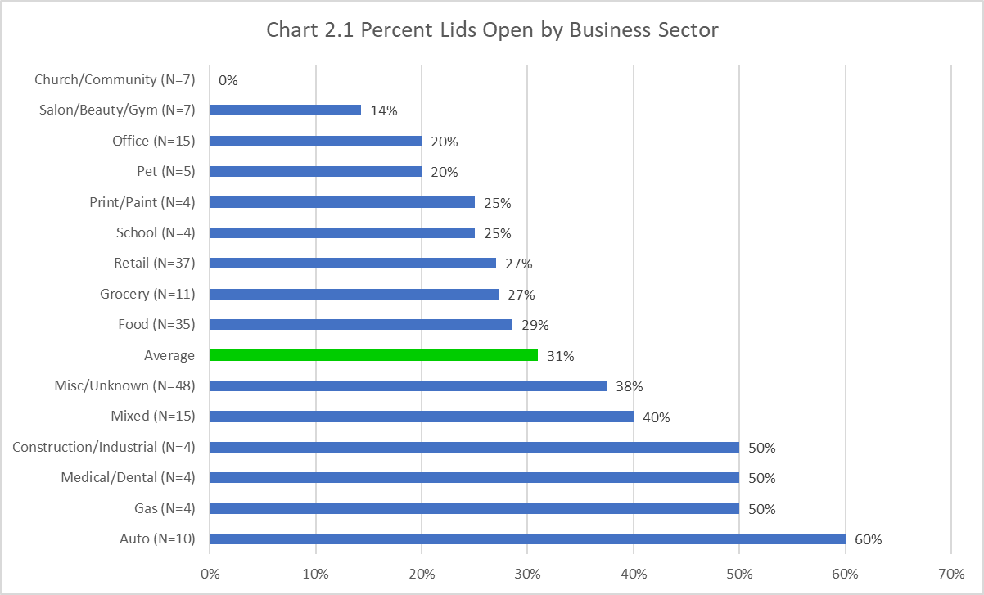

*Statistical significance is the probability that the observed result would have occurred due to sampling error alone. A p-value lower than 0.05 indicates statistical significance.

The percentage of containers leaking and/or damaged (Chart 2.2) ranged from 0% at Church/Community Centers (n=7), Pet/Veterinarian (n=5), Print/Paint (n=4), Schools (n=4), Gas Stations (n=4), and Automotive businesses (n=10) up to 27% at Grocery Stores (n=11).
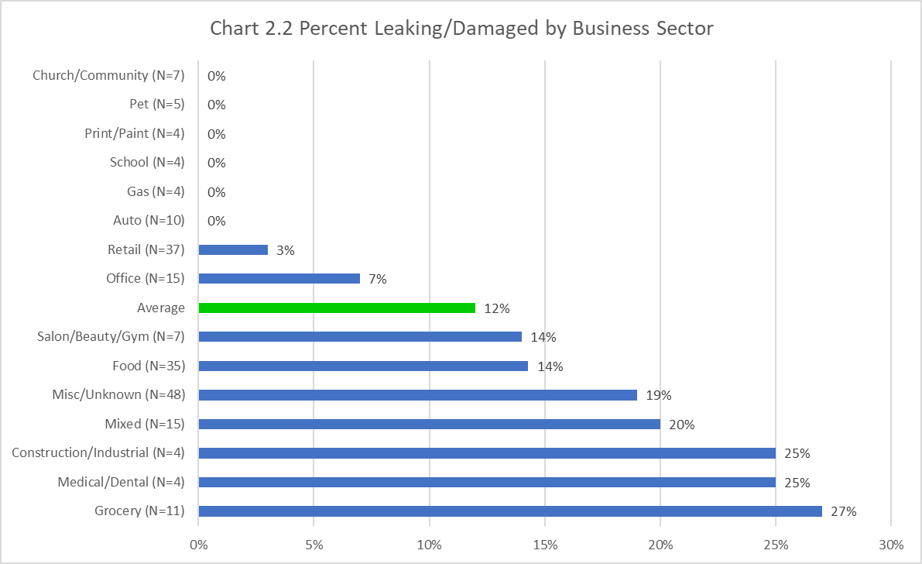

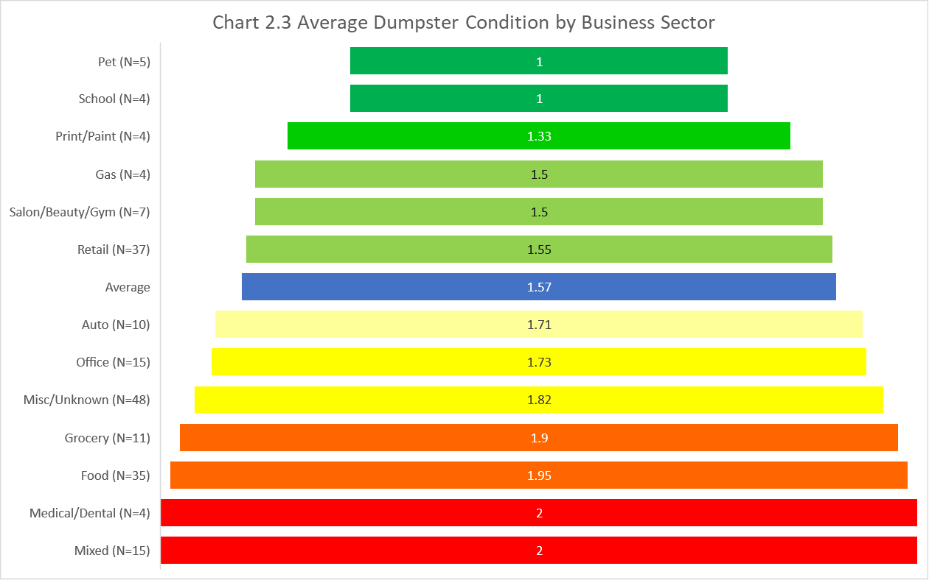
Average rated dumpster condition (Chart 2.3) ranged from 1.0 at Pet/Veterinarian (n=5) and Schools (n=4) to 2.0 at Medical/Dental (n=4) and Mixed Use (n=15).

Use by single or multiple businesses
Information on dumpster use by single or multiple businesses was collected from 154 businesses in Bellevue, Kirkland, and Sammamish to learn whether the amount of businesses using one waste account affects site condition. Sites with multiple businesses were significantly more likely to have lids open (p=0.02) and significantly more likely to have containers that were leaking/damaged (p=0.02) compared to sites with a single business.
Notably, multiple-business sites had open lids in 39% of observations compared to 22% of single-business sites. Multiple- business sites had leaking/damaged containers in 23% of observations compared to 9% of single-business sites (Chart 3.1).
Average dumpster condition at multiple-business sites was 1.87 compared to an average condition of 1.60 at single- business sites.
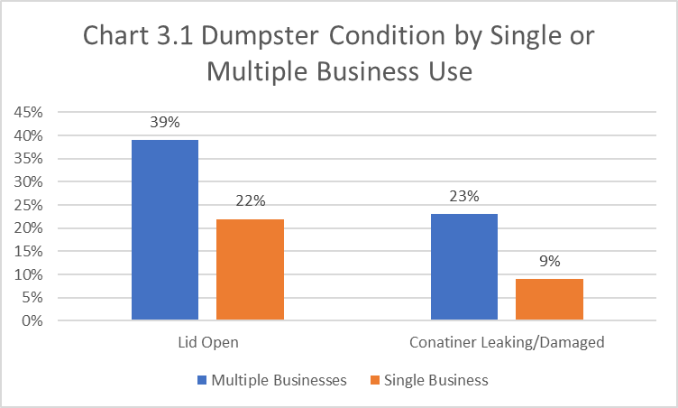

Container type
Information on whether a business had an oil container was collected at 148 businesses in Bellevue and Sammamish. Of those, 31 businesses had oil containers. Businesses with oil containers were almost equally likely as businesses without oil containers to have dumpster lids open. However, businesses with oil containers were significantly more likely (p <
.01, n=148) to have containers that were leaking or damaged compared with businesses without oil containers (Chart 4.1). Businesses with oil containers had an average dumpster condition rating of 2.26 compared to an average of 1.56 at businesses without oil containers, representing a statistically significant difference (p < .01, n=148).
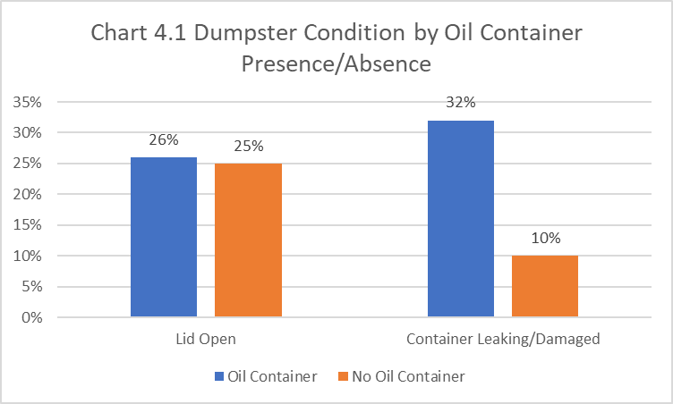

Presence of proper labels
Of the 146 businesses for which label information was collected, 144 had proper labels displayed on the container. No further analysis was conducted based on presence of labels, due to lack of available data.
- Lid status
Lid status was evaluated for 373 businesses to determine whether lids were open or closed. Open lids were observed at 128 businesses (34%). Businesses with open lids also had significantly worse (p < 0.01, n=138) dumpster condition ratings than businesses with lids closed, indicating a higher degree of water quality concerns at containers with open lids.

Container status
Container status was evaluated for 391 businesses to determine whether containers were leaking or damaged. Leaking/damaged containers were observed at 47 businesses (12%). The average dumpster condition at containers that were leak and damage free was 1.57, and the average condition at containers with leaks and/or damage was 2.48, representing a statistically significant difference.

