DON’T WAIT TO INFLATE

partnerS & PalS CAMPAIGN toolkit
PUGET SOUND STARTS HERE 2023

ABOUT THE CAMPAIGN
The “Don’t Wait to Inflate” campaign reminds drivers to check tire pressure monthly for safety, savings – and salmon!
The “Don’t Wait to Inflate” campaign reminds drivers that keeping tires properly inflated is safer for people and salmon. Checking tire pressure monthly and adding air if needed improves road safety, tire wear and gas mileage and helps keep toxic pollutants out of our waterways.
New studies show a chemical in tire rubber called 6PPD-q is killing coho salmon. By keeping your tires properly inflated you can reduce tire dust and protect salmon and Puget Sound. Visit DontWaitToInflate.org to learn more.
HOW TO USE THIS TOOLKIT
Share on your social and outreach channels and let us know how it is going! We can feature and amplify each other’s reach and audiences. This toolkit gives partners and pals of Puget Sound Starts Here resources to share the “Don’t Wait to Inflate” message through links to the campaign landing page, videos, downloadable creative assets, hashtags and sample social media.
Questions? Contact team members Justine Asohmbom, Heather Trim, Aaron Hussman, Mary Rabourn and get connected. We will post updates at DontWaitToInflate.org and the Puget Sound Starts Here Blog – Communities working together to raise awareness of how our everyday actions impact waterways in the Puget Sound region and what we can do to prevent pollution.

LINKS
DON’T WAIT TO INFLATE CAMPAIGN WEBPAGE VANITY URL (redirects to English webpage):
www.DontWaitToInflate.org
WEBPAGE URL BY LANGUAGE:
English: https://www.pugetsoundstartshere.org/DontWaittoInflate
Korean: https://www.pugetsoundstartshere.org/DontWaittoInflate/ko.html
Spanish: https://www.pugetsoundstartshere.org/DontWaittoInflate/sp.html
Vietnamese: https://www.pugetsoundstartshere.org/DontWaittoInflate/vt.html
VIDEOS
- English (:15 sec) animated video: Don't Wait to Inflate! Properly inflated tires improve road safety and even protect our coho salmon.
- English (:30 sec) animated video: Don't Wait to Inflate! Properly inflated tires improve road safety and even protect our coho salmon
- English (2:51) how-to video: Don't wait to inflate! How to check car tire pressure monthly and add air ASAP if needed
CREATIVE ASSET DOWNLOADS ON FLICKR
- DWTI Campaign Album: STORM Outreach | Flickr (PSSH Don't Wait to Inflate Tire Care Campaign 2023 album) of brand, image, video & social media creative assets
- Photostream of all STORM Flickr images: STORM Outreach | Flickr (main Flickr site)

HASHTAGS

#DontWaitToInflate
#CheckTirePressureMonthly
#CheckTiresMonthly
#PugetSoundStartsHere
#TireTuesday (as relevant)
#TireTipTuesday (as relevant)

SAMPLE SOCIAL MEDIA POSTS View / Download graphics from Flickr album
Want to drive safer, save money & help keep toxic pollutants out of our waterways? Don’t wait to inflate! Check your tire pressure monthly & add air if needed. Learn more at www.DontWaitToInflate.org  #DontWaitToInflate #CheckTirePressureMonthly #CheckTiresMonthly #PugetSoundStartsHere | 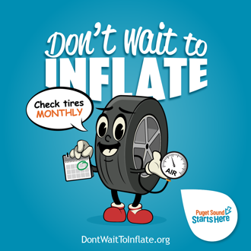
Don’t wait to inflate – your car tires, that is! Properly inflated tires result in better fuel efficiency & safer driving AND they help keep toxic pollutants out of our waterways – protecting local coho salmon.  📢Check your tire pressure monthly & add air ASAP if needed! It’s easy. To learn how & where to add air, go to www.DontWaitToInflate.org  #DontWaitToInflate #CheckTirePressureMonthly #CheckTiresMonthly #PugetSoundStartsHere | 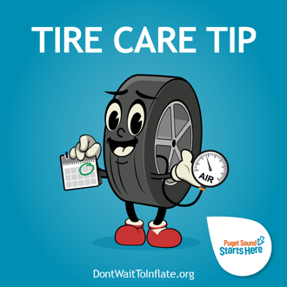
Here’s a monthly reminder to check the air pressure in your tires & inflate if needed! You can drive safer, save money, and help save our coho salmon from toxic pollutants in tire dust by keeping your tires properly inflated. It’s important to check monthly & add air if needed ASAP.  Learn more at www.DontWaitToInflate.org  #DontWaitToInflate #CheckTirePressureMonthly #CheckTiresMonthly #PugetSoundStartsHere | 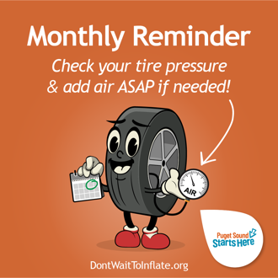
Fall in love with tire care this fall by checking the air pressure in your tires monthly! Think you can’t do it? We promise, you can! It’s quick and easy to check your tire pressure and add air if the pressure is low. Learn how by watching this brief video from Puget Sound Starts Here:  https://www.youtube.com/watch?v=9hMrOFzxuiU  #DontWaitToInflate #CheckTirePressureMonthly #CheckTiresMonthly #PugetSoundStartsHere | 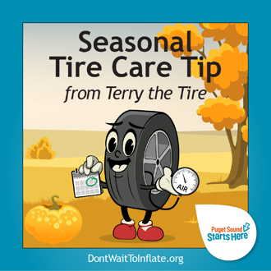
Cozy up to tire care this winter & check your air pressure monthly! You’ll stay safer on our wintery roads with properly inflated tires. If you’re not sure how, or to find an air station near you, visit www.DontWaitToInflate.org  #DontWaitToInflate #CheckTirePressureMonthly #CheckTiresMonthly #PugetSoundStartsHere | 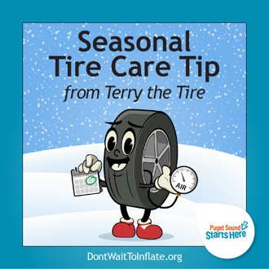
Put a spring in your car’s step with proper tire care! Properly inflated tires help you stay safer on the road when driving on Puget Sound roadways this spring…no winter…no summer…oh, it’s spring again! No matter what our indecisive weather does, it’s important to check your tire pressure monthly & add air if needed ASAP.  Find a nearby air station & learn more at: www.DontWaitToInflate.org  #DontWaitToInflate #CheckTirePressureMonthly #CheckTiresMonthly #PugetSoundStartsHere | 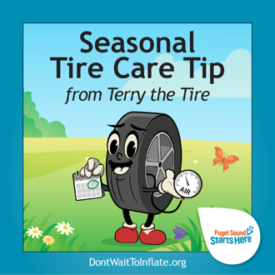
Here’s a hot tip to keep your tires cool this summer! Check your air pressure in the morning before the day heats up for the most accurate reading.  Have you checked your air pressure this month? If not, take a few minutes to check & add air ASAP if needed. It’ll save you money at the pump & your tires will last longer. Learn more at www.DontWaitToInflate.org  #DontWaitToInflate #CheckTirePressureMonthly #CheckTiresMonthly #PugetSoundStartsHere | 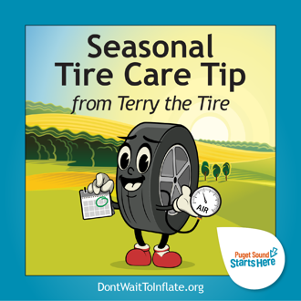

BRAND ASSETS View / Download from Flickr album
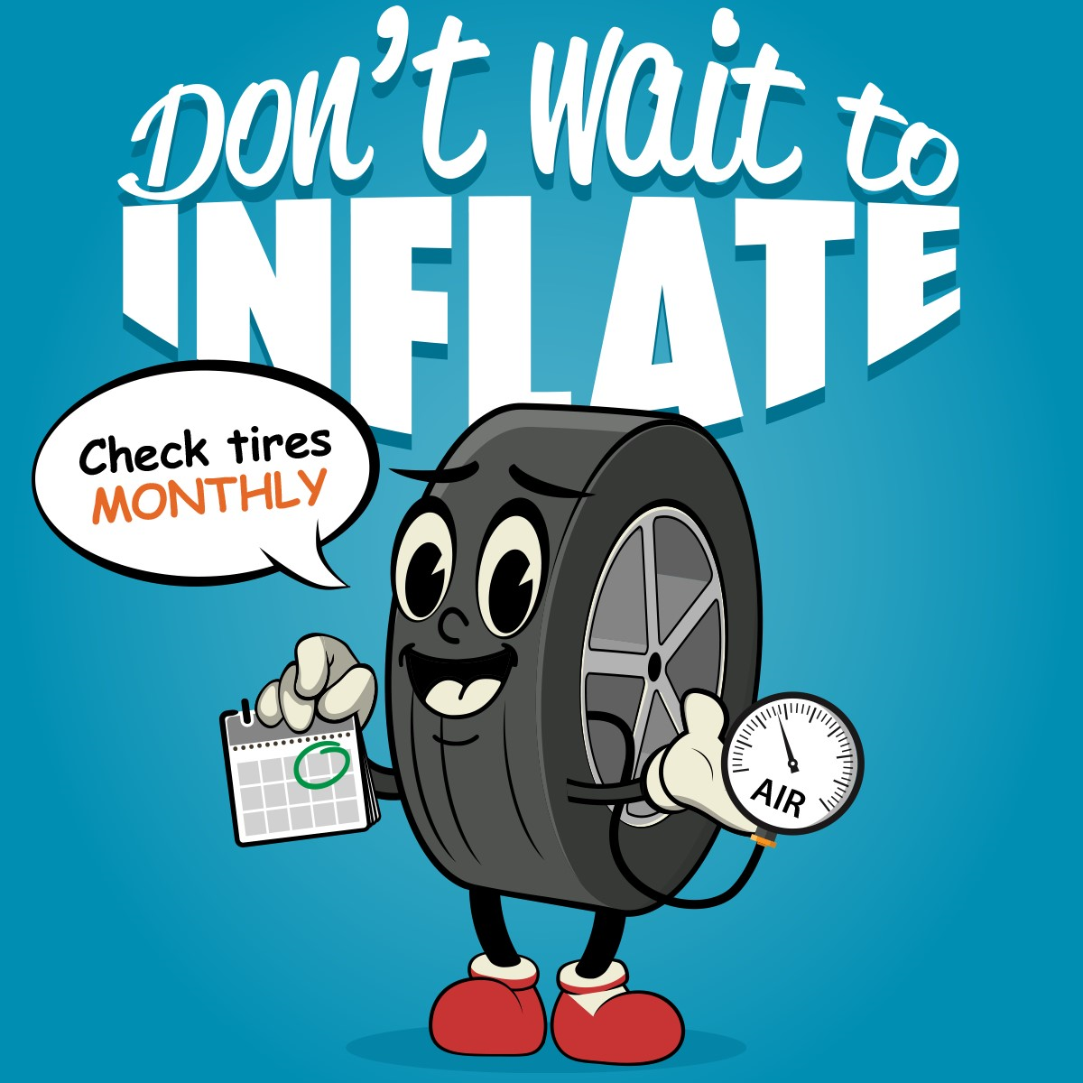 | 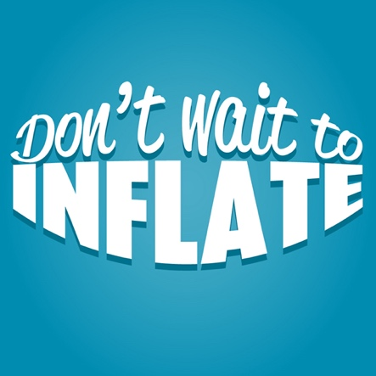 | 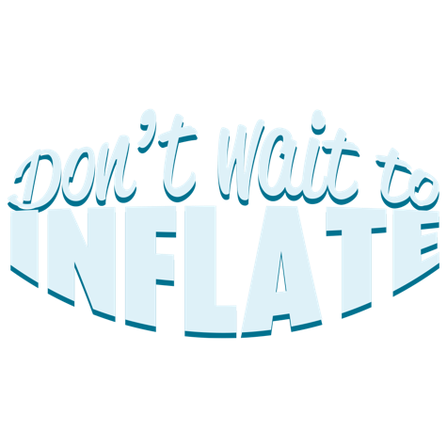
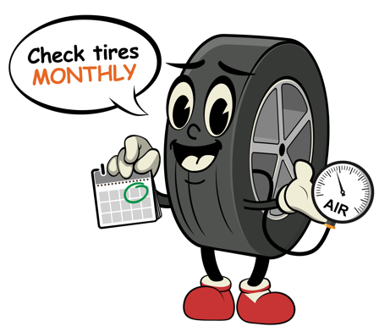 | 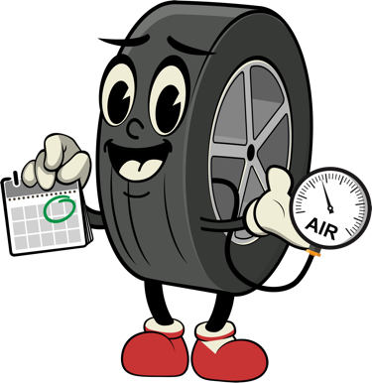 | 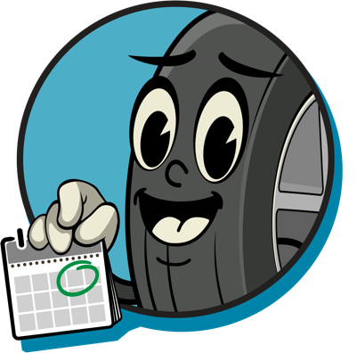
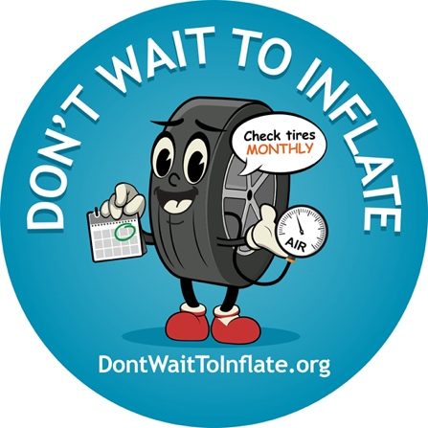

IMAGES View / Download from Flickr album
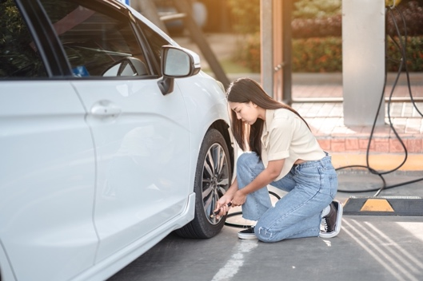 | 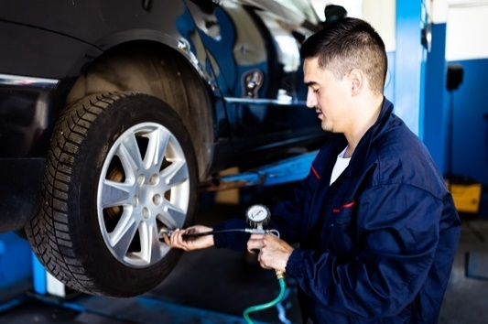

INTERACT WITH US ON SOCIAL
www.facebook.com/PugetSoundStartsHere
https://www.instagram.com/pugetsoundstartshere/
#PugetSoundStartsHere
@PugetSoundStartsHere

ADDITIONAL project materials & toolkits
STORM Resource Reservoir: https://www.pugetsoundstormgroup.org/  Puget Sound Starts Here website: https://www.pugetsoundstartshere.org/  Window clings or stickers: contact the partners or Mary.Rabourn@kingcounty.gov | 