SWPPP Checklist for Element 9: Control Pollutants (2.1.9)

POLLUTANTS
☐ Identify pollutants on site
☐ List pollutants and their location if known
☐ Describe how pollutants will be handled
☐ Describe how pollutants will be disposed of
☐ Include materials produced from existing buildings if project is not new construction

Example Pollutant List
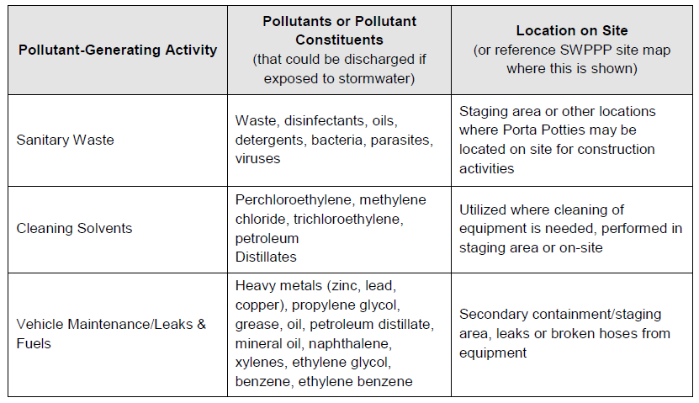
☐ Identify potential wastes – See Department of Ecology “General Contractor Tip Sheet”
☐ Identify dangerous waste
See guidance on dangerous waste: https://ecology.wa.gov/Regulations-Permits/Guidance-technical-assistance/Dangerous-waste-guidance/Common-dangerous-waste/Construction-and-demolition
☐ Include list of containers (fire cabinets, containment pallets etc.) required to contain dangerous waste with appropriate labels
☐ Identify disposal method for dangerous waste and how disposal will not cause contamination of stormwater
☐ Establish container and location for building/demolition debris
Consider access routes for subcontractors, routine trash pickup and security from vandals/dumping
Make sure containers have lids or are stored under cover
☐ Identify how concrete washout will be contained and where washout will be located
☐ Label waste containers
☐ Design washout size based on the concrete capacity and hauling frequency
☐ Include a plan for collecting wash water (Water from rinsing tools, paint, shop towels, etc.)
Example: tools shall be cleaned over a ground cloth or into a tub
☐ Describe how potentially polluting materials will be contained and covered to prevent stormwater pollution.
☐ Identify BMPs used to control pollutants, the inspection and maintenance plan, and responsible staff. Include subcontractors and utility work, if necessary
Fueling and Maintenance of Vehicles and Equipment
☐ Estimate the volume of fuel on-site
☐ Include secondary containment summary
☐ Include the capacity of secondary containment
☐ Describe secondary containment structures.
☐ Describe maintenance frequency and expectations
☐ Outline Spill Plan information
☐ Describe spill prevention and control measures, operational and structural
☐ List reporting agencies, clean up contractor and risks to water resources nearby
☐ Describe fueling, maintenance, and equipment repair BMPs
☐ Describe inspection and maintenance plan for fuel containment and identify responsible staff.

Wheel Wash System
☐ Describe location and uses for wheel wash or tire bath system BMPs at construction site.
☐ Describe disposal methods for wastewater, including a permit from Sewer if needed
☐ List and describe BMPS, inspection and maintenance plan, and responsible staff.

pH Modifying Sources
☐ Identify all pH-Modifying Sources including concrete washout, acid washes and grinding or cutting
☐ Attach any written approval from the Department of Ecology regarding chemical treatment
☐ Describe BMPS, inspection and maintenance plan, and responsible staff.

