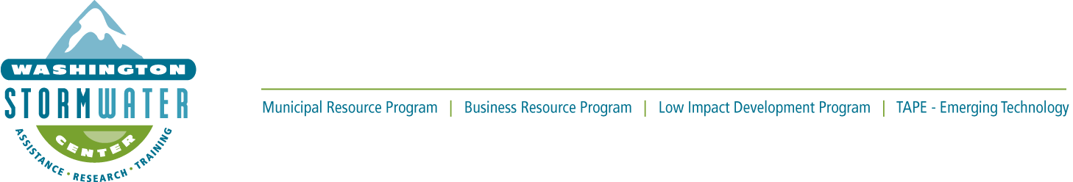

Washington State Education & Outreach Annual Meeting
Oct. 18,2023, 9: 30 am - 11:00+ am
Meeting Zoom Link
Phone number: 253 – 215 - 8782
Meeting ID: 396 821 2848
Passcode: 487862

Agenda
(Please remember to mute yourself during presentations.)
9:30 am – 9:40 | Welcome and Introductions.  Take a quick poll.
9:40 – 9:55 | Meghan Havko, Spokane City’s Wastewater Management Education Coordinator will share new outreach documents created for construction site stormwater concerns in Eastern Washington.
9:55 – 10:15 | Laurie Devereaux, Bellevue Stream Team Program Administrator will share her the development process of her Dumpster Outreach campaign.
10:15 – 10:20 | Break
10:20 – 10:40 | Eric Lambert, Stormwater Partners, Clark County Public Works Clean Water Outreach Specialist will share his Student Video Contest program’s development process.
10:40 – 11:00 | Jane Dewell, Port of Seattle will ID language groups and BMPs that made sense for the Port neighbors in the lower Duwamish area, as well as QR codes to translations.
11:00 – 11:15 | Anne Melrose, WSC Statewide Municipal E&O Coordinator will stay on for anyone wanting more time for conversation about E&O needs.

Meeting Evaluation Link

Presenter’s Bios:
Meghan Havko: City of Spokane, Education Coordinator for wastewater and stormwater. Meghan has been with the city for just over a year and a half, previously working at the regional health district for 5 years. She has a background in public health and social marketing working within a variety of communities and has spearheaded local and regional campaigns aimed at creating behavior change.
Laurie Devereaux: Bellevue. Stream Team Program Administrator. Laurie has over 25 years of experience in education and outreach for utilities. She provides stormwater outreach & education and manages a volunteer stream monitoring program. Laurie is on the Steering Committee for STORM (STormwater Outreach for Regional Municipalities) and values the expertise, creativity, and advantages of working on educational and behavior change projects with regional partners.

Eric Lambert: Clark County Public Works, Clean Water Outreach Specialist. Eric primary role is to ensure Clark County meets its NPDES E&O requirements. He also leads Stormwater Partners of SW Washington, a regional group collaborating on outreach and education, and serves on the steering committee for the Clean Rivers Coalition, a group Oregon and SW Washington jurisdictions, agencies and nonprofits working build the bridge between clean water and health communities through education and engagement.

Jane Dewell: Senior Manager, Marine Stormwater Utility, Port of Seattle. Jane has been at the Port since 2016 and helped to set up the new stormwater utility, which focuses on stormwater regulation and asset management and rehabilitation. Prior to joining the Port, she worked for Washington and Hawaii state governments on stormwater, pollution prevention, hazardous waste minimization, and local government outreach. She has also worked in environmental consulting and for non-profits helping to develop stormwater and pollution prevention programs.

Anne Melrose: Washington Stormwater Center’s Statewide Municipal Education & Outreach Coordinator. Anne is celebrating her first year on the job. Previously she worked for the San Joaquin Air District in Fresno, the Conservation District in Coarsegold and the UC Extension office in Davis, CA. She spent nearly a decade on a forest study called the Sierra Nevada Adaptive Management Project as a member of their Public Participation Team. She has also taught Middle School Science in Los Angeles.

